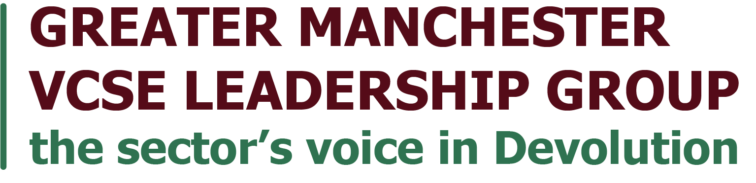
2024 Greater Manchester VCSE Sector Manifesto - Initial Ideas

1. Context
This paper contains some policy ideas and suggestions from the GM VCSE Leadership Group. Consultations in the GM VCSE Leadership Group meetings assembled a number of popular manifesto ideas however this now is to be built on to create a broader, full Greater Manchester VCSE Manifesto.
The GM VCSE Leadership Group was set up to promote the role and involvement of the VCSE sector and communities in Greater Manchester devolution. Leadership Group members are Sector Leaders who can act as ‘catalysts and connectors’ on behalf of the Sector. The Leadership Group’s purpose is ending inequality in Greater Manchester in a generation, and to support the VCSE sector to play its full part in Greater Manchester. The Group has a vision of a connected VCSE sector delivering a more socially just Greater Manchester that is addressing the priorities of its communities.

2. Value of the sector
We write this paper in the knowledge that the Voluntary, Community and Social Enterprise sector is a partner in GM development and prosperity. Our GM VCSE sector offers:
- A positive shift for a thriving society. We offer our commitment to the vision of a city region in which all residents are valued, included and safe to lead good lives. The VCSE sector represents the fabric of society; communities of locality, identity, experience and interest.
- Our ability to engage, inform, consult, support and mobilise residents and communities as they exist, not just at scale but also at a granular level – we reach the nooks and crannies not reached by politicians or the public sector;
- Our wide and deep knowledge of the barriers to attaining equality of outcomes, which are experienced by different communities, and how to overcome them;
- Our expertise in social and economic innovation and our learning from trialling new approaches to difficult problems; we have evidence and the expertise to innovate, the ideas have just not been mainstreamed yet
- Our independent resources including volunteers and funding which we can align with public and private sector resources to achieve common goals.
  - Volunteer time in Greater Manchester is conservatively valued at £692 million per annum
  - 75% of VCSE organisations in Greater Manchester pay the Real Living Wage
  - 75,610 paid employees (equal to 46,122 FTE) in the voluntary, community and social enterprise (VCSE) sector in Greater Manchester.
  - 496,609 volunteers (including committee members and trustees)

3. 2024 Initial Manifesto Ideas

3.1 Collaborate with our communities
- We need to see a new community-centred model of driving opportunity and change. This new model must put emphasis on consistent co-production and co-design with local people and the organisations that represent and support them.
- We need to see a collaborative model of working across GM with partners to ensure that the VCSE plays a full role in single settlement and public service reform.
- Ensure those with lived experience, are included in policy making, using guidance developed by GM Equalities Alliance.
- Tackle gender-based violence through social programmes, such as those promoting ‘positive masculinity’.
- Build on our GM VCSE Accord agreement, connecting our Greater Manchester VCSE sector of 17,000 charities and community groups with the Greater Manchester Combined Authority and the Greater Manchester Health and Social Care Partnership.

3.2 Cost of living crisis
- The GM VCSE Fair Funding Protocol, ensures funding given to the VCSE sector is paid fairly, includes inflationary uplifts, and doesn’t pass on cuts disproportionately to the voluntary sector amongst other commitments. Act on these commitments and promote this agreement with local authorities and the NHS Integrated Care System. We need to see parity of esteem with NHS providers.
- Greater wealth-building through progress with the Greater Manchester Community Wealth Hub.
- Progress in working towards the recommendations of the Independent Inequalities Commission, including building a Community Investment Platform and Inclusive Ownership Hub.

3.3 Resilient workforces for resilient communities
- We need to see workforce support programmes for the Voluntary, Community and Social Enterprise Sector, viewing workers in GM as “one workforce” and by supporting key development programmes such as the 10GM workforce development programme.
- We need to see wages keep up with the cost-of-living crisis, with Greater Manchester becoming the UK’s first Living Wage City-Region.
- Support for improving the capacity of local VCSE organisations to tender for skills and employment funding.

3.4 Make our economies inclusive
- Establish Greater Manchester as the first ‘social enterprise city region’
- Adopt the Socio-Economy Duty which places a legal obligation on public bodies to consider the social and economic impact of their decisions
- Set up a Socio-Economic Disadvantage Action Network to sit alongside other thematic networks such as Homelessness and Food Securities Action Network

3.5 Making homes for all
- Good homes for all – create not a “housing strategy” but a “strategy for homes” We know that a good home is not only bricks and mortar, but a sense of security, stability and of community built through the connections forged in our homes and the places we live.
- Identify key elements of social infrastructure, including important VCSE community centres in GMCA’s Spatial Framework
- Invest and support Community-led Housing and Neighbourhood Planning efforts
- Influence large developers to boost community ownership in their plans for big developments
- Co-ordinate with VCSE sector organisations to tackle the issue of homelessness across Greater Manchester

3.6 Sustainable community organisations
- Provide specific grants, and initiatives for VCSE community centres and organisations to become Net Zero.

3.7 Full and equitable role in the future of health delivery
- A driving role in health provision – such as the Alternative Provider Collaborative
- Mental health Leadership Group missions
- Maximise the role of people and communities to sustain and grow preventative activity (including through activities such as Social Prescribing, universal and targeted wellbeing and prevention work) which addresses the wider social determinants of health and / or activities which support the individuals and groups who are at greatest risk of poor health.

Appendix 1:
- Ensure recommendations from 2021 Independent Inequalities Commission progress, with increased urgency.
- Commitment to more co-production and co-design with local people, rather than the use of management consultants, or the blunt instrument of conventional contract reviews.
- Pay us fairly – ‘Parity of Esteem’ (in line with NHS providers, incl. timely Cost of Living increases). Make commitment to invest into VCSE organisations in place.
- “One workforce” – scale up workforce strategies in Greater Manchester to include the VCSE sector. Support VCSE-specific programmes like the 10GM one
- Establish Greater Manchester as a ‘social enterprise city region’.
- Be the first city region to adopt the socio-economy duty.
- Good homes for all – create not a “housing strategy” but a “strategy for homes” - communities that exist around and in the local places where people live are just as important as bricks and mortar of a house. VCSE groups and communities are key to this.
- Set up a Socio-Economic Disadvantage Action Network
- Turn VCSE agreements into action (i.e. The National Compact and Code of Conduct; recently agreed Fair Funding Protocol; the Commissioning Framework, the GM VCSE Accord, GM NHS Integrated Care Partnership strategies). Progress on agreements internally at all levels and in the 10 boroughs to deliver benefit in all the communities they were designed to serve.

See appendix 1
See greatermanchester-ca.gov.uk/media/4605/the-next-level-good-lives-for-all-in-greater-manchester.pdf and democracy.greatermanchester-ca.gov.uk/documents/s26701/14%20GMCA_Report_Inclusive%20Ownership%20Hub%20May%202023%20final.pdf

